

ACCESSIBILITY GUIDE DOWNLOAD FESTIVAL 2026
Donington Park, Castle Donington, Derby, DE74 2RP

ACCESSIBILITY GUIDE CONTENTS
WELCOME TO DOWNLOAD FESTIVAL 2026 4
TICKETS AND VEHICLE PASSES 5
FORMS OF ID REǪUIRED 6
PRESCRIBED MEDICATION 6
FOOD AND DRINK 7
BAGS IN THE ARENA 8
ESSENTIAL COMPANIONS 8
GROUND CONDITIONS AND WEATHER 9
FESTIVAL OPENING AND CLOSING TIMES 9
HOW TO GET TO DOWNLOAD 10
CAR PARKING FOR CAMPING TICKET CUSTOMERS 11
PARK & GO AND UNLOAD & GO (FOR ACCESSIBLE CAMPSITE A ONLY) 12
PARKING FOR CAMPERVAN TICKET CUSTOMERS 13
CAR PARKING FOR WEEKEND ARENA AND DAY TICKET CUSTOMERS 14
TAXIS AND PRIVATE PICK-UP/DROP-OFF 14
COLLECTING YOUR WRISTBANDS AT THE BOX OFFICE 15
ROUTINE SEARCHES 18
INTERNAL SITE TRANSPORT 19
ACCESSIBLE CAMPSITES A AND B 20
GENERAL CAMPSITES 22
ACCESSIBLE FACILITIES IN THE ARENA 22
ASSISTANCE DOGS 25
BRITISH SIGN LANGUAGE: PERFORMANCE INTERPRETING SERVICE 25
MEDICAL ASSISTANCE AND WELFARE 26
LEAVING THE ARENA, LEAVING THE FESTIVAL AND RE-ENTRY 26
DOWNLOAD FESTIVAL APP 27
THE ACCESSIBILITY TEAM 28
HOW TO GET HELP 28
WHAT 3 WORDS 29
ACCESSIBILITY MAP 30
BOX OFFICE, CAMPSITE AND CAR PARK MAP 31

WELCOME TO DOWNLOAD FESTIVAL 2026

We are looking forward to welcoming you to this year’s Download Festival.

Please take the time to read this accessibility guide carefully. It contains essential information including what to bring to the festival, how to access the festival site, and details of the facilities available inside.

All accessible facilities and locations are marked on the accessibility site map which you can find in this guide, on the Download website and in the Download Festival App.
Please remember to share this accessibility guide with your essential companion, as it is important that they also read the information in this document.

If you have any questions that aren’t answered in the guide, please email the accessibility team at: accessibility@downloadfestival.co.uk

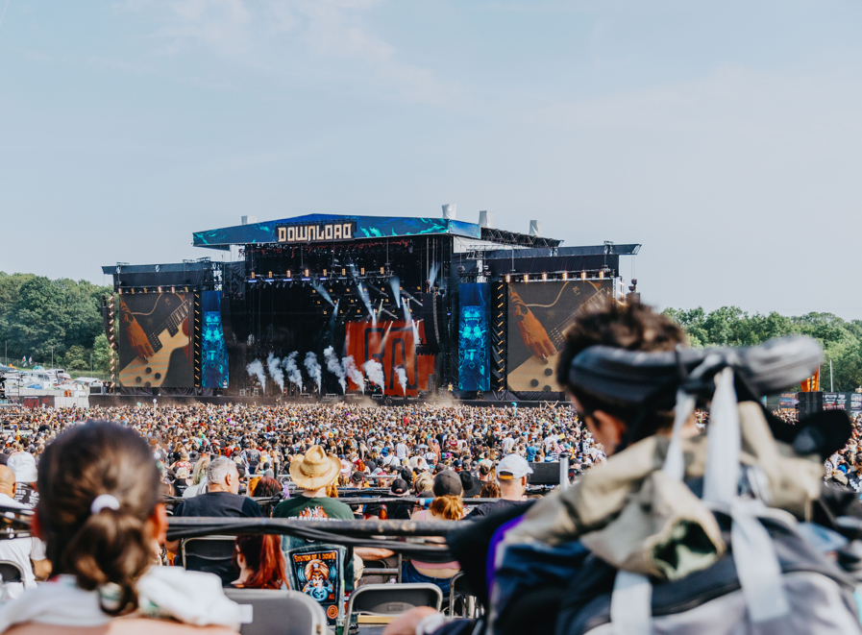

TICKETS AND VEHICLE PASSES

DOWNLOAD YOUR TICKETS
Please download the Ticketmaster app on your phone and preload your ticket before arriving at the festival. This will ensure that you won’t have to worry about having a good signal on your phone at the festival.
Please open your phone’s app store and search Ticketmaster UK and then download the app.
We will need to scan the QR code on your digital ticket when you arrive in order for you to enter the festival. Please remember to make sure your phone is charged.

APPROVED ACCESSIBLE FACILITIES
Please find the email you received from us with confirmation of your approved accessible facilities.

To help you find this email, it was sent from accessibility@downloadfestival.co.uk and the subject line is Download Festival 2026 Accessibility Approval Confirmation.

If you cannot find the email, please contact us at accessibility@downloadfestival.co.uk before leaving home.

CAR PARK, DROP OFF AND CAMPERVAN VEHICLE PASSES
Where approved, you will receive your accessible car park, drop-off or campervan pass, in advance, by post.

For more details about parking go to the parking sections later in the guide.
Please make sure that the pass is clearly displayed in the windscreen or rear-view mirror of the vehicle.

FORMS OF ID REǪUIRED

Please ensure you bring one of the following forms of identification with you:

- Nimbus Access Card
- Current passport
- Current driving licence
- Download Festival Digital Access Pass and Photo ID

You will be asked to present your form of identification when collecting your wristbands.

PRESCRIBED MEDICATION
If you're bringing prescribed medication with you, please ensure that your medication is in the correct packaging with the dispensary sticker intact and issued in your name.
If you need to bring in loose medication or medication that’s not in its original packaging, you will need to bring the prescription(s) with you.

MEDICAL MARIJUANA
Medical marijuana, prescribed for daily use, may be brought into the festival. Please bring the medication in its prescribed form together with the original prescription supporting its use for the entire duration of your time at the event. You should be prepared to present this, along with identification matching the name on the prescription, on entry and at any time during the festival if requested.

If your marijuana is prescribed in a form that requires either vaping or smoking, please be courteous and mindful of those around you. Please note, vaping and smoking are not permitted on the raised viewing platforms.

STORAGE FOR REFRIGERATED MEDICATION
Refrigerated storage for medication is available at the following locations:
- Accessible Campsite A in the campsite manager’s office
- Accessible Campsite B in the campsite manager's office
- District X in the hospital
- The arena in the first aid tent

This facility is only for the storage of medication that requires refrigeration.

STORAGE FOR NON-REFRIGERATED MEDICATION
If you need to store non-refrigerated medication, it can be stored in the campsite manager’s office in both Accessible Campsites A and B, the hospital in District X, or at the arena first aid tent.

CONTROLLED SUBSTANCES
If you wish to store any controlled substances, they can be stored at the hospital in District X or at the arena first aid tent. Due to licensing regulations, they cannot be stored in the campsite manager’s office in either Accessible Campsites A or B.

LABELLING
All medication must be clearly labelled with the following:
- your full name
- your date of birth
- your phone number
- Your essential companion’s full name if you wish for them to collect and store your medication.

Medication will be signed in and out by a manager and will only be issued to the named customer or their essential companion, where applicable.

FOOD AND DRINK

FOOD
All Download customers are permitted to bring a small amount of food for personal consumption into the arena.
Accessibility customers are permitted to bring additional food in excess of the usual amount into the arena.
(This increased allowance applies to accessibility customers only and not to essential companions or friends and family).

DRINK
All Download customers are permitted to bring a sealed, unopened 500ml bottle of water or soft drink into the arena.

Accessibility customers are permitted to bring one sealed, unopened bottle up to 1.5l of water or soft drink into the arena.
This increased allowance applies to accessibility customers only and not to essential companions or friends and family.
You will be able to refill your water bottles at water points situated around the site.
No alcohol may be taken into the arena.

ON SITE SUPERMARKET – CO-OP
The Co-op supermarket will be located on-site in District X.

Co-op opening hours:
- Wednesday 12:00 to 03:00
- Thursday - Sunday 07:00 to 03:00

BAGS IN THE ARENA
For security reasons, we ordinarily only permit customers to bring a small bag (A4 size) into the arena.

Accessibility customers are entitled to bring a bigger bag into the arena. (One bag only per accessibility customer).
This larger bag allowance is granted to the accessibility customer only. Please understand that this change to the policy is for the benefit of you, the accessiblity customer, only, and we cannot extend it to other members of your party.
The bag can be carried by you or someone on your behalf, if preferred.

Please remember that your bag will be searched on entry into the arena.

ESSENTIAL COMPANIONS
If you have been approved to attend Download Festival with an essential companion, please ensure they arrive with you. You will not see a ticket for your essential companion in the Ticketmaster app.

Your essential companion must be present with you at the box office to receive their wristband.

Please ensure that your essential companion is willing and able to fulfil all your requirements, as needed, and will be able to assist during an evacuation or other emergency.
If Download Festival finds evidence that your essential companion is not attending for the purpose of supporting your needs, they may be asked to leave the festival. Before taking this action, we will inform you, share the evidence used to reach our decision, and discuss alternative means for your needs to be supported.

GROUND CONDITIONS AND WEATHER

Download Festival is an outdoor event, and most of the terrain is grass. Solid pathways or hard ground are absent in some parts of the event site. Many of the stages and entertainment areas are in areas with inclines or slopes.
There are designated accessible routes around the festival site. They are a mix of trackway and hardcore tracks.
In the event of rain, it is important to know that the terrain will likely become muddy and wet, making it harder to navigate. We recommend using wheelchairs or mobility scooters suitable for this terrain and bringing the appropriate emergency tyre repair kit.
Whilst we hope for sunshine, please pack gear for all kinds of weather.
We advise all customers with mobility difficulties to use the available internal transport service.

FESTIVAL OPENING AND CLOSING TIMES

Campsites
- Wednesday 10th June 12:00 – Monday 12:00 15th June.
Arena
- Friday 12th 12:00 – 23:00
- Saturday 13th 10:00 – 23:00
- Sunday 14th 10:00 – 23:00

HOW TO GET TO DOWNLOAD

FESTIVAL SITE ADDRESS
Download Festival is located at Donington Park, Castle Donington, Derby, DE74 2RP

BY CAR
If you are driving to the festival, please read the driving guide on the Download website. In addition, your vehicle pass will show which gate you should go to and which signs you should follow as you approach the festival.

TRAINS AND FESTIVAL SHUTTLE BUSES
Festival shuttle buses run from East Midlands Parkway Railway Station to the festival site. The festival shuttle bus drop-off point is located at the transport hub at the East Entrance.

East Midlands Parkway Station is approximately 9 miles from the festival site. For accessibility information at this station please go to their website.

The internal accessible shuttle bus picks up from the transport hub. Please see the Internal Transport section for details of the internal shuttle bus routes.

COACH
The official coach partner for Download Festival is Big Green Coach. Please visit their website for coach travel information.
Coaches will drop passengers at the transport hub at the East Entrance.
The internal accessible shuttle bus picks up from the transport hub. Please see the Internal Transport section for details of the shuttle bus routes.

TAXI AND PRIVATE PICK-UP/DROP-OFF
Taxis are available from East Midlands Parkway Railway Station. Please see the Taxis and Private Pick-Up/Drop-Off (Cars and Taxis) section for details of the taxi and private pick-up/drop-off locations.

CAR PARKING FOR CAMPING TICKET CUSTOMERS

This section provides information on where to park if you are camping at Download. If you have requested accessible parking, you will receive a car park pass either in the post or by email.

The Box Office, Campsite and Car Park Map shows the location of all campsites and car parks.

For information about the different car park passes and where they let you park, please continue reading this section.

PURPLE CAR PARK PASSES (CAMPING CUSTOMERS)
If you have been allocated parking in the Purple Car Park, you will receive your car park hanger pass by post. Please ensure it is hanging from your rear view mirror on arrival.

Your car park pass will tell you what signage to follow and which gate to enter through. If you have a Purple Car Park pass you will enter through Purple Gate.

If you are staying in Accessible Campsite A, you will be able to choose between Park & Go and Unload & Go. For more details about these options, go to the Park & Go and Unload & Go section.

ACCESSIBLE WEST CAR PARK PASSES (CAMPING CUSTOMERS)
If you have been allocated parking in the Accessible West Car Park, you will receive your car park hanger pass by post. Please ensure it is hanging from your rear view mirror on arrival.
Your car park pass will tell you what signage to follow and which gate to enter through. If you have an Accessible West Car Park pass, you will enter through West Gate 2.

If you have been approved to stay in Accessible Campsite B and are driving, your designated car park is the Accessible West Car Park.

Please be aware that, due to health and safety restrictions, it is not possible to Unload & Go in Accessible Campsite B. There will be staff available to assist with bags.

NORTH/WEST CAR PARK PASSES (CAMPING CUSTOMERS)
If you have received a North/West Car Park Pass by email, you will have access to the dedicated accessible parking areas in the North or West Car Parks.

You can either show the car park pass on your phone to the steward on arrival or you can print the pass at home and display it in your windscreen.

Your pass will tell you what signage to follow and which gate to enter through. It will be different depending on which car park you choose to go to.

RIP CUSTOMERS
If you are an RIP customer, you will receive separate parking instructions from the VIP Nation team. Please follow these instructions.

PARK & GO AND UNLOAD & GO (FOR ACCESSIBLE CAMPSITE A ONLY)

If you are staying in Accessible Campsite A and are parking in Purple Car Park, you can choose either to:

- park in Purple Car Park and make your own way to the campsite using the internal buggy service if required (Park & Go) or
- drive into Accessible Campsite A, unload your bags, then drive to Purple Car Park (Unload & Go).

You can also choose between these options if you are being dropped off at the Purple Pick Up/Drop Off point by a taxi or car.

Park & Go
If you choose this option, you will go directly to the Purple Car Park to park. The distance from the Purple Car Park to the Accessible Campsite A entrance is approximately 330m over hardstanding. You can either make your own way to the campsite or use the internal transport which will drop you at the Accessible Campsite A entrance.

Please note that Park and Go will be a quicker process than Unload and Go, particularly on Wednesday.

Unload & Go
If you choose this option, you will drive onto Accessible Campsite A to unload your belongings.
Please display your Accessible Campsite A Vehicle pass in your windscreen. You will receive this additional pass along with your Purple Car Park or Drop Off Pass. We recommend bringing this pass even if you have not yet decided whether you will use the Unload & Go option.

Please be aware that, due to the large number of customers attending Download, there will be significant queues to use Unload & Go, particularly on Wednesday when the campsite opens.

At peak times, this queue could be as long as two to three hours.

For health and safety reasons, you will not be permitted to drive to your pitch. Instead, your vehicle will be held in a designated area of the campsite. The campsite team will be on hand to assist you, if required.

Unload & Go will only be available while it is safe for vehicles to enter the campsite. Once the campsite is at a certain level of occupancy, health and safety guidelines prevent us from allowing additional vehicles to enter. The latest that Unload & Go will be available is 1pm on Thursday. If you arrive after this time, you will be able to Park & Go instead.

To reduce queuing times, we require the driver to move their vehicle from the campsite to the car park as soon as your belongings have been unloaded.

PARKING FOR CAMPERVAN TICKET CUSTOMERS

This section provides information on where to park if you are staying in a campervan at Download.

STAYING IN THE ACCESSIBLE CAMPERVAN SITE
If you have been approved for an accessible campervan space, you will receive your campervan hanger pass by post. Please ensure it is hanging from your rear view mirror on arrival.

Your pass will tell you what signage to follow and which gate to enter through. You will enter through Purple Gate.

Your campervan may be searched on arrival.

STAYING IN THE GENERAL CAMPERVAN SITE
You will have purchased and received a general campervan pass.
Please follow the arrival instructions included with that pass. Your campervan may be searched on arrival.

CAR PARKING FOR WEEKEND ARENA AND DAY TICKET CUSTOMERS

This section provides information on where to park if you are not camping at Download. For information about the different car park passes and where they let you park, please continue reading this section.

The Box Office, Campsite and Car Park Map shows the location of all campsites and car parks.

ACCESSIBLE BLUE CAR PARK PASS (NON-CAMPING CUSTOMERS)
If you have been allocated parking in the Accessible Blue Car Park, you will receive your car park hanger pass by post. Please ensure it is hanging from your rear view mirror on arrival.
Your pass will tell you what signage to follow and which gate to enter through. You will enter through Blue Gate.

ACCESSIBLE SOUTH CAR PARK PASS (NON-CAMPING CUSTOMERS)
If you have been allocated parking in the Accessible South Car Park, you will receive your car park hanger pass by post. Please ensure it is hanging from your rear view mirror on arrival.
Your pass will tell you what signage to follow and which gate to enter through. You will enter through Grey Gate.

TAXIS AND PRIVATE PICK-UP/DROP-OFF

If you are being dropped off by taxi or a private car, you should use one of the dedicated pick-up/drop-off points. Each point is marked on the Accessibility Map.

If you have not requested accessible pick-up/drop-off, please find information about the general pick-up/drop-off location on the website.

PURPLE PICK-UP/DROP-OFF PASS
If you are being dropped off in the Purple Pick-Up/Drop-Off area, you will receive your car park pass by post. Please make sure that the driver has the pass clearly displayed on their dashboard.
Your pass will tell you what signage to follow and which gate to enter through. You will enter through Purple Gate.

ACCESSIBLE WEST PICK-UP/DROP-OFF PASS
If you are being dropped off in the Accessible West Pick-Up/Drop-Off area, you will receive your car park pass by post. Please make sure that the driver has the pass clearly displayed on their dashboard.
Your pass will tell you what signage to follow and which gate to enter through. You will enter through Black Gate.

ACCESSIBLE BLUE PICK-UP/DROP-OFF PASS
If you are being dropped off in the Accessible Blue Pick-Up/Drop-Off area, you will receive your car park pass by post. Please make sure that the driver has the pass clearly displayed on their dashboard.
Your pass will tell you what signage to follow and which gate to enter through. You will enter through Blue Gate.

COLLECTING YOUR WRISTBANDS AT THE BOX OFFICE

BOX OFFICE INFORMATION

You can collect your festival wristband and accessibility wristbands from any box office at the festival. The locations of all box offices are marked on the Accessibility Map.

When you get to the box office, please have the Ticketmaster app open showing your ticket and QR code. Please also have your photo I.D ready.
If you have been approved to bring an essential companion, they must attend the box office with you to collect their wristbands.
Please be aware that it is likely that there will be queues at all box offices, particularly on Wednesday and Friday. Seating, accessible toilets and water will be available close to the box offices. All box offices have a lowered counter and a hearing loop.

WHICH BOX OFFICE SHOULD I GO TO?
Which box office you go to will depend on where you arrive at the festival.

The Box Office, Campsite and Car Park Map shows the location of all box offices.

PURPLE GATE BY CAR/TAXI/CAMPERVAN (CAMPING CUSTOMERS)
If you are entering through Purple Gate, there are three box offices.

- If you are parking in the Purple Car Park (and not using Unload & Go) or being dropped off at the Purple Pick Up/Drop Off point, please go to the Purple Box Office to collect your festival and accessibility wristbands.
The Purple Box Office is located in the Purple Car Park and is approximately 330m from Accessible Campsite A. There will be internal transport from the box office to the campsite. Our team of helpers will also be on hand to assist you with your bags and equipment.
- If you are staying in Accessible Campsite A and choose to use the Unload & Go option, please go to the Campsite A Box Office located inside Accessible Campsite A to collect your festival and accessibility wristbands.

- There is an accessibility box office in the Accessible Campervan site. If you have been approved to stay in a campervan in this area, please go to this box office to collect your festival and accessibility wristbands. You will then be directed to your plot.

WEST GATE OR BLACK GATE BY CAR/TAXI (CAMPING CUSTOMERS)
If you are entering through West Gate or Black Gate, the accessible West Box Office is located at the entrance, before you go through the search lanes. You must collect your festival and accessibility wristbands your wristbands before you go through the search lanes.

The accessible West Box Office is approximately 325m from Accessible Campsite B. Our team of helpers will also be on hand to assist you with your bags and equipment.

BLUE GATE BY CAR/TAXI (DAY OR WEEKEND ARENA CUSTOMERS)
If you are entering through Blue Gate, the Blue Box Office is located next to the Blue Car Park. Please go to the Blue Box Office to collect your accessibility wristbands. It is approximately 70m from the blue day accessible arena entrance.

If you are a Day Ticket holder, you will not be given a festival wristband. You will only need to collect your accessibility wristbands. You will need to show your festival ticket each time you enter the arena.

GREY GATE BY CAR (DAY OR WEEKEND ARENA CUSTOMERS)
If you are entering through Grey Gate, there is a box office located at the South Entrance. If you are parking in the South Car Park or staying in the standard campervan site, go to this box office to collect your accessibility wristbands. The box office is approximately 190m from the South Entrance.

NORTH GATE 1 BY CAR (CAMPING CUSTOMERS)
If you are entering through North Gate 1, there is a box office located at the East Entrance. If you are parking in the North Car Park, go to this box office to collect your accessibility wristbands.

TRANSPORT HUB
If you are arriving at the Transport Hub, details of where to go to collect your wristbands are set out below.

If you are camping in Accessible Campsite A, the eco campsite or camping plus, please take the internal shuttle bus to the Purple Car Park. There is an accessibility box office located here where you can collect your festival and accessibility wristbands.
This box office is approximately 330m from Accessible Campsite A. There will be internal transport from the box office to the campsite. Our team of helpers will also be on hand to assist you with your bags and equipment.
If you are camping in Accessible Campsite B, blue, black, yellow (quiet) or the mini moshers campsite, please take the internal shuttle bus to the West Entrance. There is an accessible box office at this entrance before you go through the search lanes. You can collect your festival and accessibility wristbands here.
This box office is approximately 325m from Accessible Campsite B. Our team of helpers will also be on hand to assist you with your bags and equipment.

If you are camping in the red, orange or purple campsites, please go to the East Entrance. There is a box office located here where you can collect your festival and accessibility wristbands.

If you are a Day or Weekend Arena Ticket Holder, please take the internal shuttle bus to the Blue Day Car Park. There is a box office located here where you can collect your festival and accessibility wristbands.

The locations of all box offices and the transport hub are marked on the Box Office, Campsite and Car Park Map.

BOX OFFICE OPENING TIMES

Box office opening and closing times are different depending on which box office that you are going to. Please note that times are subject to change.

Purple Box Office
Wednesday and Thursday 08:00 – 22:00
Friday, Saturday and Sunday 08:00 – 20:00

Campsite A Box Office
Wednesday and Thursday 08:00 – 22:00
Friday 08:00 – 20:00
Saturday and Sunday Closed

Accessible Campervan Box Office
Wednesday and Thursday 08:00 – 22:00
Friday 08:00 – 20:00
Saturday and Sunday Closed

West Box Office
Wednesday and Thursday 08:00 – 22:00
Friday 08:00 – 20:00
Saturday 08:00 – 18:00
Sunday 08:00 – 16:00

East Box Office
Wednesday and Thursday 08:00 – 22:00
Friday, Saturday and Sunday 08:00 – 20:00

Blue Box Office
Wednesday and Thursday Closed
Friday, Saturday and Sunday 08:00 – 20:00

South Box Office
Wednesday and Thursday 08:00 – 22:00
Friday, Saturday and Sunday 08:00 – 20:00

ROUTINE SEARCHES
Festival attendees are subject to a search of their bags, mobility aids and person.
You may request a female or male member of security to complete the search. Dogs may also be present. There will be accessible toilets nearby.
To avoid any delays or issues, please review the prohibited items list that you cannot bring to the festival by visiting our website.

INTERNAL SITE TRANSPORT

An internal shuttle bus service will be available between the dedicated bus stops around the site. Seating and water will be provided at each shuttle bus stop.

There are seven bus stops. They are located at:
- Accessible Campsite A
- Purple Car Park
- District X central
- District X south
- West Entrance (including Accessible Campsite B)
- Transport Hub
- Blue Car Park

The Shuttle bus operates during the following hours:
Wednesday 09:00 – 03:30
Thursday 09:00 – 03:30
Friday 09:00 – 03:30
Saturday 09:00 – 03:30
Sunday 09:00 – 03:30
Monday 09:00 – 12:00

An accessible buggy service will be available to take customers from the Purple Car Park to Accessible Campsite A. The buggy service will also be available to take customers to District X and the Co-op, to supplement the shuttle bus service.
Please note that buggies cannot enter the arena or District X.

ACCESSIBLE CAMPSITES A AND B

GENERAL INFORMATION
There are two accessible campsites at Download this year: Accessible Campsite A and Accessible Campsite B. If you do not know which Accessible Campsite you are staying in, please contact the accessibility team at accessibility@downloadfestival.co.uk

If you have been approved for Accessible Campsite A, you will not be permitted to camp in Accessible Campsite B.

If you have been approved for Accessible Campsite B, you will not be permitted to camp in Accessible Campsite A.

Once you have collected your campsite wristband and pitched your tents, you will be able to visit friends in the other accessible campsite.
Customers in Accessible Campsite B, will be able to enter the Arena through the Accessible Campsite A arena entrance.

SETTING UP
When you arrive, you will be directed to an available camping pitch. Our team of helpers will be there to assist you. Wheelchair users and those with restricted mobility will take priority in being positioned close to the accessible walkway and facilities.

If you are staying in Accessible Campsite A, information about Unload & Go is in the Park & Go and Unload & Go section.

Due to health and safety restrictions, it is not possible to Unload & Go if you are staying in Accessible Campsite B.

You will be able to access your car throughout the weekend.

Due to space limitations, please be mindful of the size of any tents or gazebos you are bringing. You may be asked to move them if they are taking up too much space. Please consider fellow campers when setting up your pitch.

You are not permitted to camp in the fire lanes, hard standing or areas without grass.

CAMPSITE FACILITIES
The facilities listed below are available in both Accessible Campsite A and Accessible Campsite B.

Campsite Information Hub
There is an information hub staffed with a team to help answer any questions you may have during the event. It is open 24-hours a day.

Critical Power
Customers who have been approved for critical power will be positioned in a designated area. The power connections will be supplied to the approved customer’s tent at specific pitches in this area.
Please let the team know that you have been approved for this facility and they will direct you to a pitch on arrival.

Accessible Routes
Accessible routes are available, comprising a mix of existing hard standing and temporary trackway.

Medication Storage
You can store medication in the campsite manager’s office.

There is a fridge for medication which requires refrigeration.

All medication must be clearly labelled with the following:
- your full name
- your date of birth
- your phone number
- Your essential companion’s full name if you wish for them to collect and store your medication.

Medication will be signed in and out by a manager and will only be issued to the named customer or their essential companion, where applicable.

If you wish to store any controlled substances, they can only be stored at the hospital in District X or in the arena first aid tent. Due to licensing regulations, they cannot be stored in the campsite manager’s offices in the Accessible Campsite.

Please be mindful that it can take time to get around the festival site. Ensure that you have access to any emergency medication at all times.

Charging Tent
The charging tent is equipped with charging points for electric wheelchairs, mobility aids and medical devices such as nebulisers. Please note, while there is security within the campsite, the charging tent does not have dedicated supervision at all times.

Lockers
Lockers are available to book in advance.
Please go to the Download website where you will find the relevant information under the heading ‘Are lockers available?’.

Accessible Toilets and Showers
There are standard and wheelchair accessible toilets and showers. They are overseen by stewards and a sanitation team to keep them clean and restocked.

Changing Places Unit
The changing places unit includes a changing bed, toilet, sink and a hoist. Please bring your own sling if required.

Washing Facilities
Sinks are available for you to wash your hands, face, and brush your teeth.

Water Point
Drinking water points are available for you to fill up water bottles.

GENERAL CAMPSITES

All General Campsites have accessible toilets. All shower facilities, including accessible showers, are in District X. There is also an changing places unit in District X.

There is an accessible information hub in District X staffed with a team to help answer any questions you may have during the event.

ACCESSIBLE FACILITIES IN THE ARENA

ARENA ACCESSIBILITY INFORMATION HUB
There is an accessibility information hub in the arena staffed with a team to help answer any questions you may have during the event. It’s open during the arena opening hours.

You will find the hub at the Apex (Main Stage) Accessible Viewing Area.

ACCESSIBLE TOILETS AND CHANGING PLACES UNITS
Accessible toilets are located within the arena toilet blocks and accessible viewing areas. Please remember to show your accessibility wristband when a staff member asks to see it. Changing places units will be available at the Apex Stage viewing area, at the Opus Stage viewing platform and by the central toilet block in District X.

If you have the WC symbol on your Nimbus Access Card or Digital Access Pass, you will be offered a JCW Wristband (Just Can’t Wait) when you collect your accessibility accreditation. This wristband is to help you indicate to other customers and staff that you have urgent toilet requirements.

We respectfully ask that all customers be considerate of one another. Please be aware that toilet facilities will be busier during peak times such as artist changeovers.

BAR SERVICE AREAS
Accessible bar lanes with lowered service areas are available at the main festival bars. Please look out for the wheelchair symbol. You and your essential companion can access the lowered bar areas by using these lanes, which bypass the general queuing system. The lanes are staffed by security and stewards; please remember to show them your wristband.

MERCHANDISE
An accessible serving area is available at the merchandise stalls; please look out for the wheelchair signs. Your accessibility wristband will give you access to the accessible merchandise serving area.

There will also be a dedicated merchandise stand positioned within the Accessible Campsites.

FOOD
For details of specific food stalls with accessible serving points, please speak to the accessibility team at the campsite information hub.
If a food trader has been unable to adjust their vehicle to allow for a lowered service point, the staff will be available to assist you from the front of the unit. Please just ask if you need assistance and they will be happy to help.
There will be dedicated food traders positioned within the Accessible Campsites.

CASHLESS PAYMENTS
Download is a fully cashless event. You can pay by debit or credit card. You can also use Apple or Google pay if you have those set up on your phone.

ACCESSIBLE VIEWING AREAS
There are raised viewing platforms and ground level viewing areas at the following stages:
- Apex Stage
- Opus Stage
- Avalanche Stage
- Dogtooth Stage
- The Doghouse
- The Den

Raised Viewing Platform
- The raised viewing platforms are equipped with ramped access, wheelchair-accessible toilets, and charging points.
- If you have been approved for the raised viewing platform, you will receive a wristband that lets you on.
- You can bring your essential companion on to the raised viewing platform with you.
- If you have not been approved for an Essential Companion, you can bring someone else with you.
- Viewing platforms are not covered. Please dress appropriately for all weather conditions.
- If your companion needs to leave the platform temporarily (for example, to use the toilets) they will be given a temporary pass card by security to hand back when they return.
- Once the platform is at capacity a one in, one out policy will be implemented.
- Smoking, including e-cigarettes & vapes, is not permitted.
- Staff and security have the right to ask you to leave the platform if you are behaving inappropriately.

Ground Viewing Area
- Ground viewing areas are available to those who need a less crowded area and the option of sitting for short periods of time.
- The ground viewing areas are situated in front of the raised viewing platforms and are separated from the main crowds by a barrier.

- The ground viewing areas are primarily standing areas, although limited seating is available.
- If you are in the ground viewing area, you can use the accessible toilets located behind the raised viewing platform.
- If you have been approved for the ground viewing areas, you will have received a wristband that gives you access.
- Once the area is at capacity, a one in one out policy will be implemented.
- Only you and your Essential Companion (or friend) will have access to the ground viewing areas. This allows us to accommodate as many customers, who require the use of this facility, as possible.
- Staff and security have the right to ask you to leave the ground viewing areas if you are behaving inappropriately.

ASSISTANCE DOGS

Spending areas will be available for assistance dogs, located in the Accessible Campsites, behind the Apex (Main Stage) Accessible Viewing Area and in District X. Please ensure you use these spaces only and always clear up after your assistance dog, using the bins provided.

BRITISH SIGN LANGUAGE: PERFORMANCE INTERPRETING SERVICE

A British Sign Language performance interpreting service will be provided on request by fully qualified interpreters from Performance Interpreting.
If you have indicated that you require this service and have given consent for your contact details to be shared with the interpreters, they will contact you directly. This is so that you can liaise with them about what performances you want interpreted.
If you would like to be contacted by the interpreters and have not yet given your consent, please contact us at accessibility@downloadfestival.co.uk
The Performance Interpreting Team will be available at their info hub just behind the Apex (Main Stage) Accessible Viewing Area. They will be available onsite to assist and answer any queries you may have.

MEDICAL ASSISTANCE AND WELFARE

MEDICS
Medics, medical care, and supplies are available in the arena and District X. There will also be a medic on duty at the Apex Stage viewing platform.

If you require urgent medical attention, please alert a member of staff who can assist you.

WELFARE
Welfare tents are located in the arena and in District X. Experienced and caring staff are on hand to provide confidential advice about drugs, alcohol, sexual health and general assistance, counselling, and advice for anything that is troubling you.

SENSORY CALM TENTS
There are two sensory calm tents at the festival. One is located within the arena, just behind the Apex (Main Stage) Accessible Viewing Area. The other is located in District X.
The aim of these spaces is to provide a safe, low-level stimulation and recalibration zone for any customers who need to use it.

LEAVING THE ARENA, LEAVING THE FESTIVAL AND RE-ENTRY

EXTERNAL AND INTERNAL VEHICLE CURFEWS
Please be aware that at the end of each day, we must enforce strict vehicle curfews to protect the safety of everyone leaving the arena. This will impact internal transport around the festival, including the routes between the arena and Accessible Campsite B.

If you wish to avoid waiting until the vehicle curfew has been lifted, you will need to leave before the curfew begins. This will mean leaving before the headliner has finished.
Vehicle curfews will be in place as below:
- Friday 22:00 to 23.30
- Saturday 22:00 to 23:30
- Sunday 22:00 to 23:30
Please be aware that these times are subject to change at short notice.

LEAVING THE ARENA (CAMPERS)
When the main headliner concludes each evening, we recommend that customers on the viewing platforms and in the ground viewing areas wait until the initial crowd has left the arena before leaving themselves.
If you wish to use the internal transport or avoid heavy crowd movement, you will need to leave prior to the curfew times. This will mean leaving before the headliner has finished.

LEAVING THE FESTIVAL (WEEKEND ARENA OR DAY TICKET HOLDERS)
Please be aware that there may be long queues when leaving the festival by car or public transport, as vehicle curfews are necessary to allow pedestrians to leave the site safely.

ACCESSING YOUR CAR DURING THE FESTIVAL
As an accessibility customer, you will have access to your car throughout the festival. If you are a day ticket holder parking in South Car Park, you should go through the accessibility lane when coming back into the arena.

Please be aware of the vehicle curfew times listed when there may be heavy crowd movement and plan trips to your car outside of these times.

RE-ENTRY FOR CAMPING AND WEEKEND ARENA CUSTOMERS
Camping and Weekend Arena customers are allowed to leave the festival site and re-enter. Please use the same route to exit the festival as you entered.

RE-ENTRY FOR DAY CUSTOMERS
As a day ticket holder, you will not be permitted to return to the festival site once you leave.

DOWNLOAD FESTIVAL APP
Please download the festival app to your mobile phone by visiting the Apple Store or Google Play and searching for Download Festival.

The app contains helpful information, including set times, maps, and important updates by push notification.

THE ACCESSIBILITY TEAM
Our accessibility team will be on hand to look after you whilst onsite. Accessibility team members can be identified by their purple tabards.

Our accessible campsite managers are on duty, providing 24-hour cover. Please feel free to ask them any questions or report issues.
A team of campsite helpers known as the Dog Squad roam the campsite, helping unload luggage and assisting the campsite managers. During busier arrival times, the helpers may be assisting other customers and will appreciate your patience.

HOW TO GET HELP

If you need assistance, please speak to a member of festival staff.

If you want to speak to a member of the accessibility team, you can find them at one of the following locations:
- The accessible box offices (on arrival)
- The campsite accessible information hubs, which are open 24 hours
- The arena accessible information hub (open during arena opening hours)
- The District X accessible information hub which is open 24 hours
- The accessible viewing areas.
You can also contact the team by email at accessibility@downloadfestival.co.uk.

WHAT 3 WORDS
What3Words is a geocode system designed to identify any location within a resolution of approximately 3m. It is an easy way to find and share exact locations. We have listed below some key site locations for you.

You can either download the app or use the website here.
LOCATION | WHAT3WORDS
Purple Box Office | Moral.digests.expert
Accessible Campervan Box Office | Replaying.gulped.energy
Blue Box Office | Cutlets.workroom.engaging
East Entrance Box Office | Weeks.quietest.venturing
West Entrance Box Office | Grabs.manicured.slot
South Entrance Box Office | Amused.shortens.extension
Accessible Campsite A | Decisions.soups.fluid
Accessible Campsite B | Scare.functions.lake
Transport Hub | Unique.warnings.partly
Purple Car Park | Lookout.starlight.should
Blue Car Park | Frown.downsie.heartless
Purple Gate | Attends.nudge.rescue
Black Gate | Formal.thread.transmitted
Blue Gate | Coil.clattered.crumble
Grey Gate | Drums.oatmeal.treatment
Sensory Tent - Arena | Downfield.pencil.reaction
Sensory Tent – District X | Bikers.named.hotspots
CO-OP | Tonality.incursion.laminate
Medical/Welfare – District X | Moved.jetting.iteration
Welfare - Arena | Mend.tallest.groom

ACCESSIBILITY MAP

Please find the accessibility map below. A physical copy will be available at the accessibility box offices on arrival.

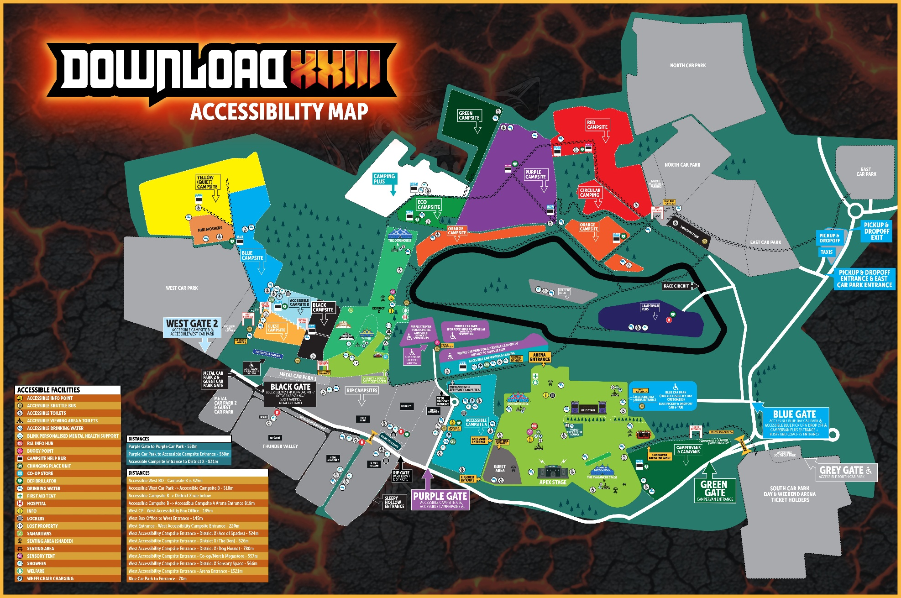

BOX OFFICE, CAMPSITE AND CAR PARK MAP
